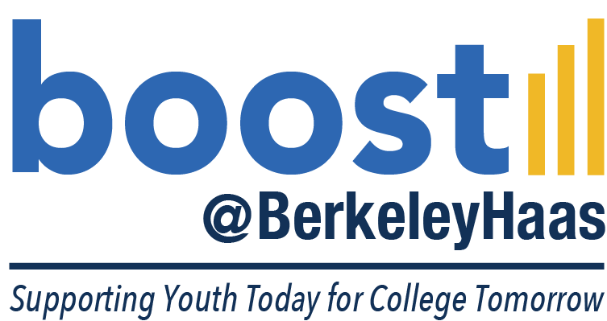

2020 Application

Dear applicant,

Thank you for your interest in becoming a part of the boost program at the Haas School of Business. This letter introduces the program and its application process.

Giving students the inspiration and confidence to dream big, boost is a four-year program that exposes under-served Bay Area high school students to the world of business and the possibility of pursuing higher education. Through lessons and group projects, students develop skills for the academic and economic success to reach their dreams.

By participating in boost, students learn about and develop skills in:

- College Readiness. Students will learn how to best navigate the path to college through various age appropriate workshops.

- Communication. Students will learn the etiquette of speaking, writing, and presenting their ideas to others.

- Computer Technology. Students will learn to use computers to conduct research, compile information, and develop PowerPoint presentations.

- Entrepreneurship. Students will learn to identify market needs and business structures, as well as how to apply that information to their own projects.

- Financial literacy. Students will learn how to track expenses, create a budget, compare and use banking services, and understand credit scores.

- World of Work. Students will create and update their resumes, how to interview effectively and how to act in a professional environment including internships.

- Teamwork. Students will learn team formation, problem-solving strategies, and inter-group communication skills that are essential to working with others.

Because boost works with students from their first-year of high school through graduation to build on increasingly sophisticated foundation of business skills and principles, the program requires a four-year commitment to ensure the students’ development in all areas of the program. To that end, the staff have developed and designed grade-level specific programs that allow students to build upon their skills each year they’re involved in the program. For example, first-year students attend a two-week summer camp. During the fall semester, these students attend workshops and participate in group activities related to program lessons two Saturdays each month with one focused on college readiness and the other working on their business case project in teams with their mentors.

This program is free to students, and only eighth grade students are eligible to apply. All 8th grade students can apply, although preference is given to low-income students from Bay Area public schools with a 2.5-3.5 GPA who would be first in their family to attend college.

To apply, students must download an application, which is available at www.haas.berkeley.edu/boost/programs.html. Students should then submit their completed application and supplemental program forms by April 3, 2019; students can submit these materials by mail or e-mail.

Qualifying applicants will receive an e-mail notification in late-April for interviews, which will take place in early May. After these interviews conclude, we will send acceptance letters to admitted students.

If, after downloading and reviewing the application, you have further questions please e-mail Trinity Wilson, Boost@BerkeleyHaas Program Coordinator & Recruiter, at trinity.wilson@berkeley.edu.

For more general information please go to the Boost website.

Thank you and good luck!

Lucas R. Abbott
Program Director
Haas School of Business
University of California Berkeley
(510) 643-4622
2020 Boost Application
(To be filled out by applicant, not parent/guardian)

This application must be completed and returned to the boost office before April 3, 2020. If you need more space, please feel free to attach additional pages to your application.
Incomplete applications will NOT be accepted.

Name __________________________ _________________________________
(Last) (First)

Address ____ ______________________________ _______________________ ________
(#) (Street) (City) (Zip code)

Home phone (_____) _____-_______ Parent/Guardian work phone (_____) _____-_______

Cell phone (_____) _____-_______

Student’s E-mail address ________________________________________ Birthday __/__/____

Parent/Legal Guardian’s E-mail address ______________________________________________

Name of Parent/Legal Guardian _____________________ Relationship to Youth ___________

Middle school ___________________________City___________________ Zip code __________

High school ___________________________City___________________ Zip code __________

Is your high school public or private?
□ Public □ Private

Current 8th grade student? YES □ NO □

What is your ethnic identity? (optional)
□ African-American/Black □ Asian □ American Indian or Alaska Native □ Native Hawaiian or Pacific Islander
□ Hispanic or Latino □ White /Caucasian
□ Other (Please specify) ________________________

How did you hear about this program? (Please specify) _____________________

Household Income Range:
□$0-$35,000 □$35,000-$65,000 □$65,000-$80,000 □Over $80,000

How many people live in your Household?
Adults________ Children (under 18) __________

What language is primarily spoken at home? _____________________

What language(s) did you learn to speak first?
□ English only
□ English and another language (Please specify) _____________________
□ Another language only (Please specify) _____________________

What is the highest level of education of your-
Mother/Guardian? □ Some High School -- □ High School Grad --□ Some College--□ Bachelors --□ Masters--□ Ph.D.
Father/Guardian? □ Some High School -- □ High School Grad --□ Some College--□ Bachelors --□ Masters--□ Ph.D.

Applicant Signature _________________________________________ Date __/__/____

Parent/Guardian Signature____________________________________ Date __/__/____

Your signature indicates approval for your child’s participation, if accepted, in the boost Program.
Applications are due by April 3, 2020 to the boost office.
Mail: Boost Program
c/o Trinity Wilson
S545 Haas School of Business
Berkeley, CA 94720-1900

SHORT ANSWER QUESTIONS
On a separate sheet of paper please thoroughly answer the following questions using complete sentences:

1. Please list your interests, hobbies, special skills, sports, etc. (1 paragraph only)

2. Share the one thing in your life that you are most proud of, and why? (1 paragraph only)

3. If you could have dinner with anybody, who would it be and why? (1 paragraph only)

4. What are your career interests? Why? (1 paragraph only)

5. What colleges or universities would you like to attend? Why? (1 paragraph only)

6. If you could change your community in one way, what would it be and how could you help? (1 paragraph only)

7. Why is completing college important to you? (1 paragraph only)

8. Please list other programs you are a part of or interested in other than Boost.

9. Parent/Legal Guardian- please answer the following question:
Why you are interested in this applicant being involved in boost?

Please also attach the following to your application:

- Photographs, artwork, poetry, stories, etc. that you feel reflect your personality. (Submitted material will not be returned).

- Your most current school transcript.

3. Include two recommendation letters, one from each of the following categories;
□ Education (Principal, Teacher, Counselor, etc.)
□ Non-family member (Coach, Friend, Neighbor, etc.)

Note: The letters should highlight the qualities that make the prospective a successful candidate for this program. Recommenders can submit recommendation letters via the Boost@BerkeleyHaas website under the prospective students tab.

For any questions please contact Trinity Wilson at trinity.wilson@berkeley.edu or (510) 643-9340 or check the website www.haas.berkeley.edu/boost

