Examples of Class Activities:

Twelve assessment techniques

- Applications cards - Identify a concept or principle your students are studying and ask students to come up with 1-3 applications of the principle from everyday experience, current news events, or their knowledge of particular organizations or systems discussed in the course.

- Analytic Memos - Ask students to write a one- or two-page analysis of a specific problem or issue. The person to whom the memo is written is usually identified as an employer, a client, or stakeholder who needs the analysis to make an informed decision. (Be explicit about the setting, the person, the purpose and the subject.) Students can work individually, in pairs, or small groups. Feedback should be based on 3-5 major points, using a rubric.

- Concept Maps - Concept maps are diagrams showing connections between a focal topic and other concepts learned. The main concept is in the center with connections drawn to other concepts above, below, to the side. To begin, show students a concept map that you have drawn. Discuss the main idea and connecting concepts that you have included. Next, prompt students to make a concept map beginning with the central concept (e.g. diffusion of knowledge) in the center of a blank sheet of paper. Ask them to add in other ideas (e.g. learning, delivery, action, storytelling) or concepts that come to mind. Collect the sheets anonymously. Reviewing the students’ concept maps reveals the depth of understanding that students have about course topics and how they are thinking about them.
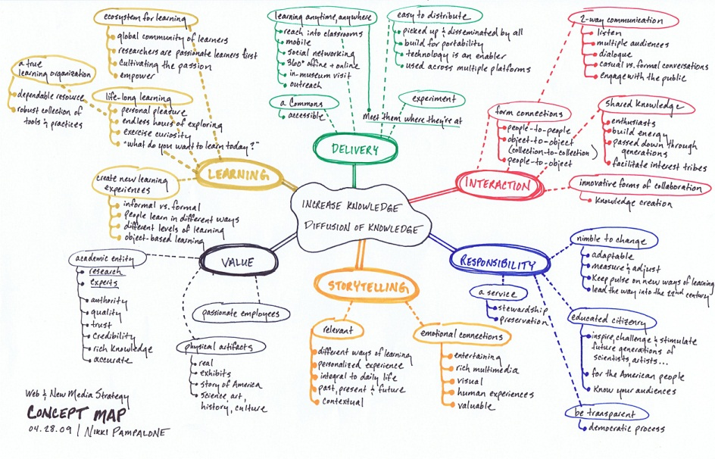
Options :
  - Create a concept map with some of the concepts missing. Provide a list for student to use to fill-in the missing concepts.
  - Repeat the concept map assignment later in the term to observe the development of student thinking.
  - Ask students to write an explanatory essay based on their maps.

- Dynamic list of questions - As a homework assignment, ask students to write a list of questions that they hope to answer by the end of the class period. During class they cross off questions as they are answered and add questions as new ones arise. At the end of class, collect the lists for a snapshot of preparation, learning and unanswered questions.

- Word Journal - Requires a two-part response. Firstly, students summarize a short text with a single word. Next students write a paragraph or two explaining why they chose that particular word to summarize the text. The complete word journal entry is an abstract or synopsis of the focus text.

- Empty outline - The instructor distributes an empty or partially completed outline either as an in-class presentation or a homework assignment. Students should have a limited amount of time to complete the missing information. Can be used at the conclusion of a class or the beginning of the next one. If the course is too large to provide individual feedback, this technique can be assigned to groups or to generate class discussion.

- Muddiest point - Similar to the Minute Paper, ask your students to answer: “What was the muddiest point in… (today’s lecture, the reading, the homework)?” Students need to identify fairly quickly (in 1-2 minutes) what they do not understand and submit it on an index card.

- One-minute paper - Pose 1-2 questions in which students identify the most significant things they have learned from a given lecture, discussion or assignment e.g. “What was the most important thing that you learned today?” The question can be very general or content specific. For example, “What question is upper most in your mind at the end of today’s class?” Their answers help you to determine if they are successfully identifying what you view as most important. Give students about 1-2 minutes and ask them to write a response on an index card, or no longer than a half page.

- Online polling - Post multiple-choice questions about key concepts on the course website. Students can select the best answer. Once they submit their answer they can view a summary graph of the class results. Share correct answers in the next class session. Students can receive credit for responding, but responses are not graded.

- Online reactions - Ask students to post their reactions to that days lecture or class discussion on a discussion board. Comments should be anonymous. Online questions can ask students to rate how challenging the topic was, to indicate an important point or identify and hard-to-follow portion of the class session.

- Think-pair-share - Pose a question, and ask student to consider the question, jotting down a few ideas, and then turn to a neighbor and share their thoughts. Next the pairs report their discussion to other pairs and, as size and time permits, to the class.

- What’s the principle? - Provide students with a few problems/examples and ask them to state the principle that best applies to the problem.

Aligning Learning Objectives and Types of Assessment

Types of Learning Objective | Types of Assessment | How to Measure
Remember  Students will be able to:  - recall  - recognize | Test items that require students to recall or recognize information:  - Fill-in the Blank  - Multiple Choice questions such as, “what is a…”, or “which of the following is the definition...  - Labeling diagrams  - Reciting (orally, or in writing) | Accuracy – correct vs number of errors  Item Analysis (at the class level, are there items that had higher error rates? Did some items result in the same errors?)
Understand  Students will be able to:  - interpret  - exemplify  - classify  - summarize  - infer  - compare  - explain | Papers, oral/written exam questions, problems, class discussions, concept maps, homework assignments that require (oral or written):  - Summarizing readings, video, etc.  - Comparing and/or contrasting two or more theories, events, etc.  - Classifying or categorizing cases, elements, processes, etc., using established criteria  - Paraphrasing documents or  - Finding or identifying examples or illustrations of a concept, principle | Scoring rubrics that identify critical components of the work and discriminate between differing levels of proficiency in addressing the components
Apply  Students will be able to:  - execute  - implement | Activities that require students to use procedures to solve or complete familiar or unfamiliar tasks; may require students to determine which procedure(s) are most appropriate for a given task. Activities include: Problem sets, labs, prototyping, simulations | Accuracy scores, Check lists, and Rubrics
Analyze  Students will be able to:  - differentiate  - organize  - attribute | Activities that require students to discriminate or select relevant from irrelevant parts, determine how elements function together, or determine bias, values or assumptions in materials. These might include:  Case studies, Critiques, Labs, Papers, Projects, Debates, Concept Maps. | Rubrics, scored by instructor, juries, external clients, employers, internship supervisor, etc.
Evaluate  Students will be able to:  - check  - critique | A range of activities that require students to test, monitor, judge or critique readings, videos, or products against established criteria or standards. These activities might include:  Journals, Diaries, Critiques, Problem Sets, Product Reviews, Case Studies. | Rubrics, scored by instructor, juries, external clients, employers, internship supervisor, etc.
Create  Students will be able to:  - generate  - plan  - produce | Research projects, essays, business plans, website designs, prototyping, portfolios. | Rubrics, scored by instructor, juries, external clients, employers, internship supervisor, etc.

